Q- Consider a system with 3 processes that share 4 instances of the same resource type. Each process can request a maximum of K instances. Resource instances can be requested and released only one at a time. The largest value of K that will always avoid deadlock is _______ .(GATE 2018)

**(A)** 1  
**(B)** 2  
**(C)** 3  
**(D)** 4

Q- In a system, there are three types of resources: E, F and G. Four processes P0, P1, P2 and P3 execute concurrently. At the outset, the processes have declared their maximum resource requirements using a matrix named Max as given below. For example, Max[P2, F] is the maximum number of instances of F that P2 would require. The number of instances of the resources allocated to the various processes at any given state is given by a matrix named Allocation.

Consider a state of the system with the Allocation matrix as shown below, and in which 3 instances of E and 3 instances of F are the only resources available.

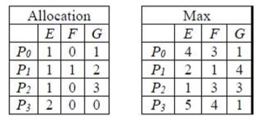

From the perspective of deadlock avoidance, which one of the following is true?(GATE 2018)

**(A)** The system is in *safe* state  
**(B)** The system is not in *safe* state, but would be *safe* if one more instance of E were available  
**(C)** The system is not in *safe* state, but would be *safe* if one more instance of F were available  
**(D)** The system is not in *safe* state, but would be *safe* if one more instance of G were available

Q- An operating system uses the Banker’s algorithm for deadlock avoidance when managing the allocation of three resource types X, Y, and Z to three processes P0, P1, and P2. The table given below presents the current system state. Here, the Allocation matrix shows the current number of resources of each type allocated to each process and the Max matrix shows the maximum number of resources of each type required by each process during its execution.

[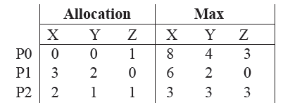](https://media.geeksforgeeks.org/wp-content/cdn-uploads/gq/2014/04/GATECS2014Q42.png)

There are 3 units of type X, 2 units of type Y and 2 units of type Z still available. The system is  
currently in a safe state. Consider the following independent requests for additional resources in the  
current state:

REQ1: P0 requests 0 units of X,

0 units of Y and 2 units of Z

REQ2: P1 requests 2 units of X,

0 units of Y and 0 units of Z

Which one of the following is TRUE?(GATE 2014)  
**(A)** Only REQ1 can be permitted.  
**(B)** Only REQ2 can be permitted.  
**(C)** Both REQ1 and REQ2 can be permitted.  
**(D)** Neither REQ1 nor REQ2 can be permitted